Connections to Record the Value for Gain and Plot the Radiation Pattern for Horn Antenna

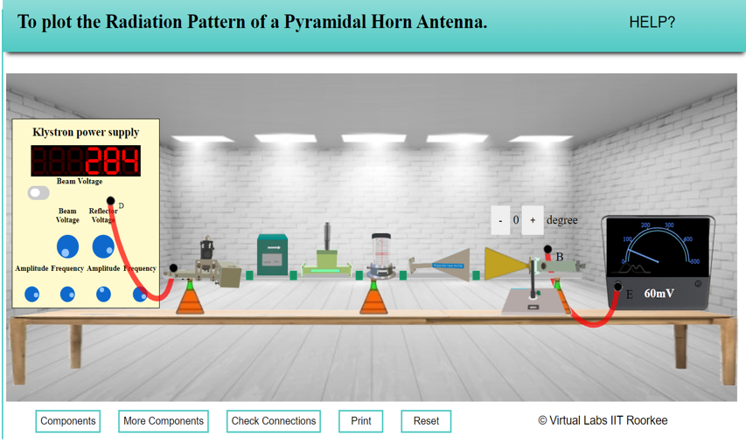

Readings for Radiation Pattern of Horn Antenna

INPUT VOLTAGE V_{T} = 330mv

Angle (degree s) | V_{R} (mv) |  | Gain (dB) = 20 log (V_{R}/V_{T})
 | Clock wise | Anticlock wise | Clock wise | Anticlock wise
0 | 61 | 60 | -14.66 | -14.81
5
10 | 56 | 55 | -15.41 | -15.56
15
20 | 41 | 40 | -18.11 | -18.33
25
30 | 21 | 20 | -23.93 | -24.35
35
40 | 16 | 15 | -26.29 | -26.85
45
50 | 26 | 25 | -22.07 | -22.41
55
60 | 41 | 40 | -18.11 | -18.33
65
70 | 61 | 60 | -14.66 | -14.81
75
80 | 21 | 20 | -23.93 | -24.35
85
90 | 11 | 10 | -29.54 | -30.37

